ANIM1283Διαβάζω τις λέξεις και αντιστοιχίζω με εικόνα

|  |  |  |
| --- | --- | --- |
| λου | λου | δι |

|  |  |  |  |
| --- | --- | --- | --- |
| πε | τα | λού | δα |

FLOWR006



|  |  |
| --- | --- |
| φύ | λλο |

FORST003

|  |  |  |
| --- | --- | --- |
| μέ | λι | σσα |

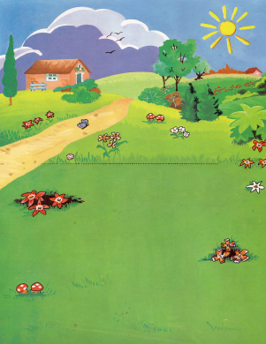

|  |  |
| --- | --- |
| **κή** | **πος** |

Διαβάζω και Αντιστοιχίζω τις ίδιες λέξεις

|  |  |  |
| --- | --- | --- |
| λου | λου | δι |

|  |  |  |  |
| --- | --- | --- | --- |
| πε | τα | λού | δα |

|  |  |  |  |
| --- | --- | --- | --- |
| πε | τα | λού | δα |

|  |  |  |
| --- | --- | --- |
| λου | λου | δι |

|  |  |  |
| --- | --- | --- |
| μέ | λι | σσα |

|  |  |  |
| --- | --- | --- |
| μέ | λι | σσα |

|  |  |
| --- | --- |
| **κή** | **πος** |

|  |  |
| --- | --- |
| **κή** | **πος** |

Αντιστοιχίζει τις Ίδιες εικόνες

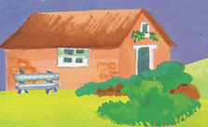



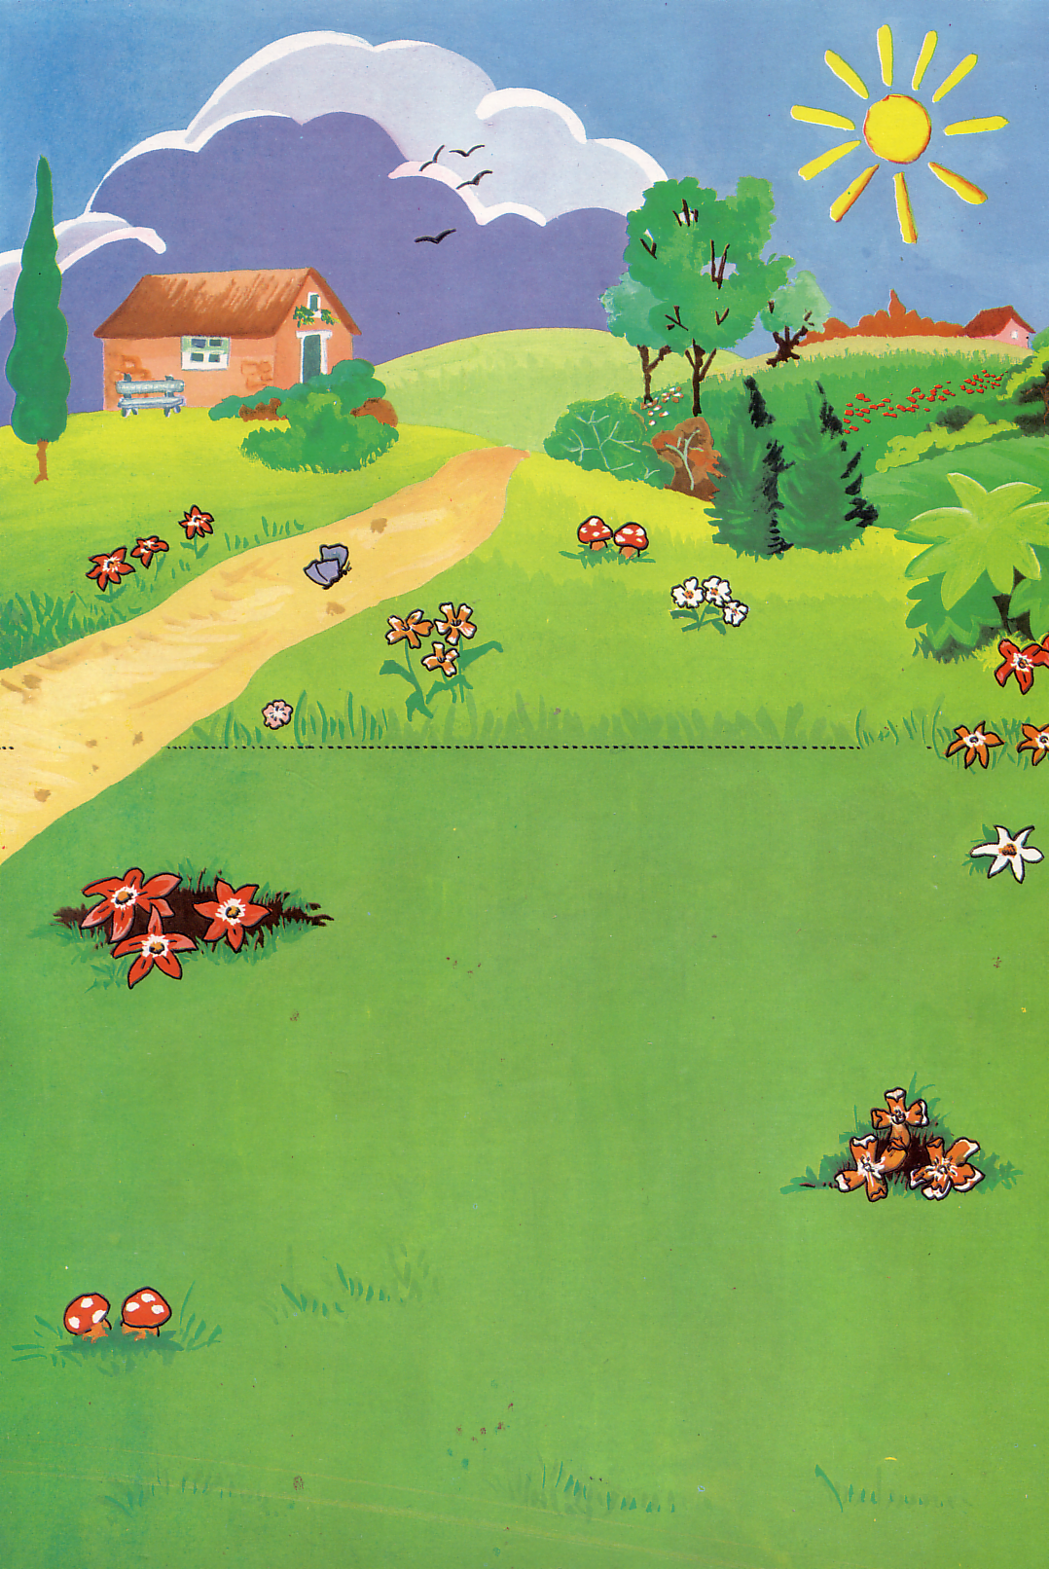

λουλούδι, ήλιος, μανιτάρι, δρόμος, σπίτι πουλιά, δέντρο,

Γράφω την λέξη που αντιστοιχίζει με την εικόνα



